

A Lightweight Agentic Schema and Anomaly Detection System for Improving Data Quality in Irish SMEs.

Configuration Manual

MSc Research Project/ (Research) Practicum/ Internship

MSc AI for Business MSCAIBUS1

Chidubem Ogechukwu Madubuko

Student ID: X24163121

School of Computing

National College of Ireland

Supervisor: Dr Muslim Jameel Syed

Date: 10th August 20

Configuration Manual
Chidubem Ogechukwu Madubuko
Student ID: X24163121

1 Introduction
This Configuration Manual provides all instruction required to operate and develop the Lightweight Agentic Schema and Anomaly Detection System for Improving Data Quality in Irish SMEs. The system runs on Windows operating system; processes datasets stored in Excel and integrates with SharePoint using Microsoft Graph API. It automatically pulls input files and generates Anomaly report and Schema report. The manual is designed so that any SME analyst or developers can reproduce the environment and run the artifact without prior knowledge of the projects.

2 System Requirements

2.1 Hardware
The system used for this thesis is a Microsoft Surface 5 powered by a 12th Gen intel Core i5-1235U processor. It is running on windows 11 Home and has a minimum of 8GB RAM.
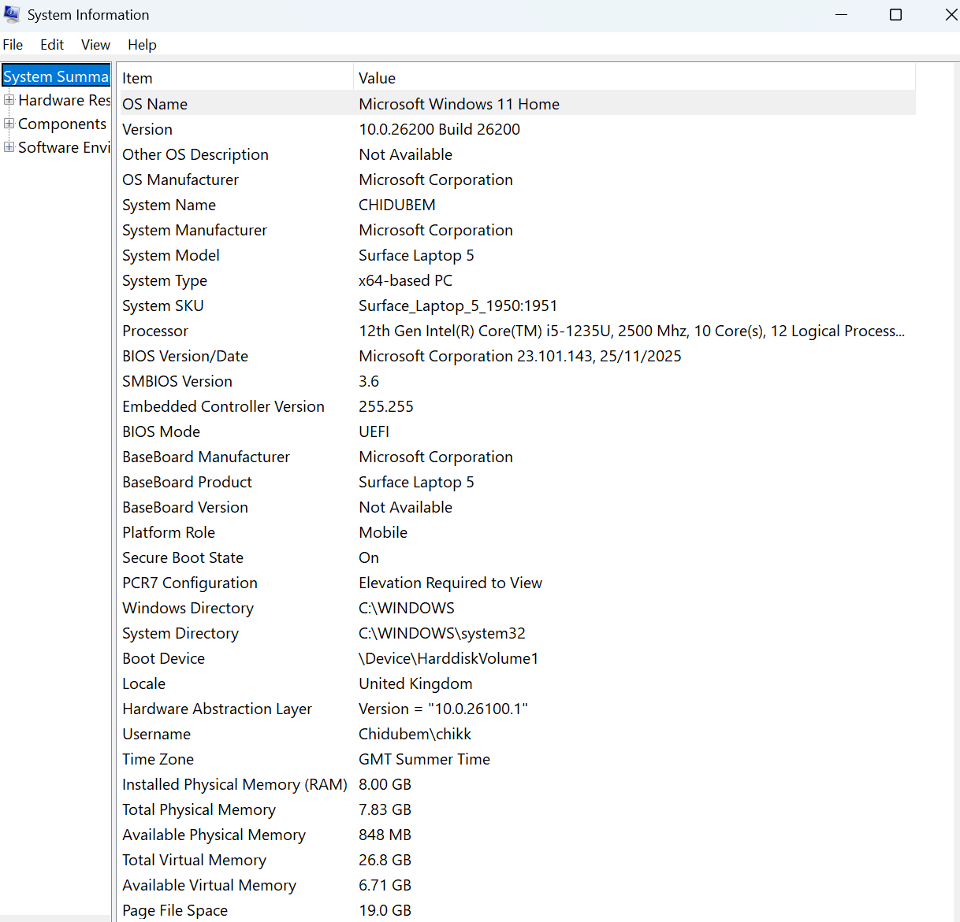
Figure 1: Hardware Requirement

2.2 Software
The software used for the development of the multi-agent system is as follows:
- Windows 11 - the operating system
- Python 3.11 - programming language
- Microsoft Graph API - the application programming Interface (API)
- Power Automate - automation layer
- Excel – viewing spreadsheet and reports.
- Visual Studio – IDE for python
- Microsoft 365 Business Licenses

2.3 Access Requirements
An Azure AD App registration is required to obtain the client ID, Tenant ID and Client Secret key. This is for SharePoint site to collaborate.

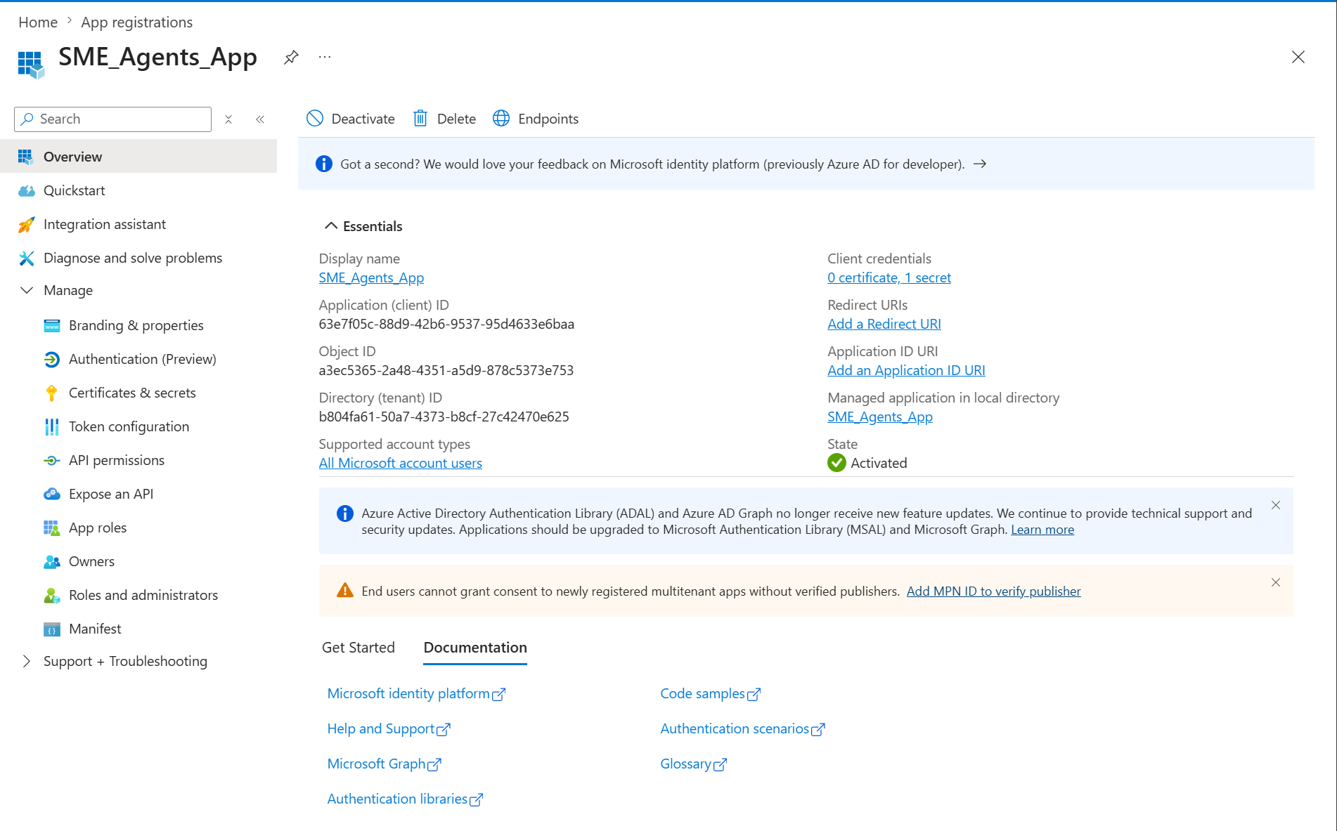
Figure 2: Azure AD App Registration

2.4 Libraries
Section | Libraries
Data processing | Pandas, NumPy, openpyxl, dateutil
Anomaly and Schema detection | Scikit-learn, NumPy, pyyaml, pandas
Visualization | Matplotlib, seaborn
Enhancement | Python-dotenv, request
Scheduling | Windows Task Scheduler, Power Automate

3 System Architecture Overview
The system follows a structured multi-layer pipeline:

3.1 User/SME Input Layer
Source includes:
- Excel/CSV files from data.gov.ie (Open Data Team, 2026)
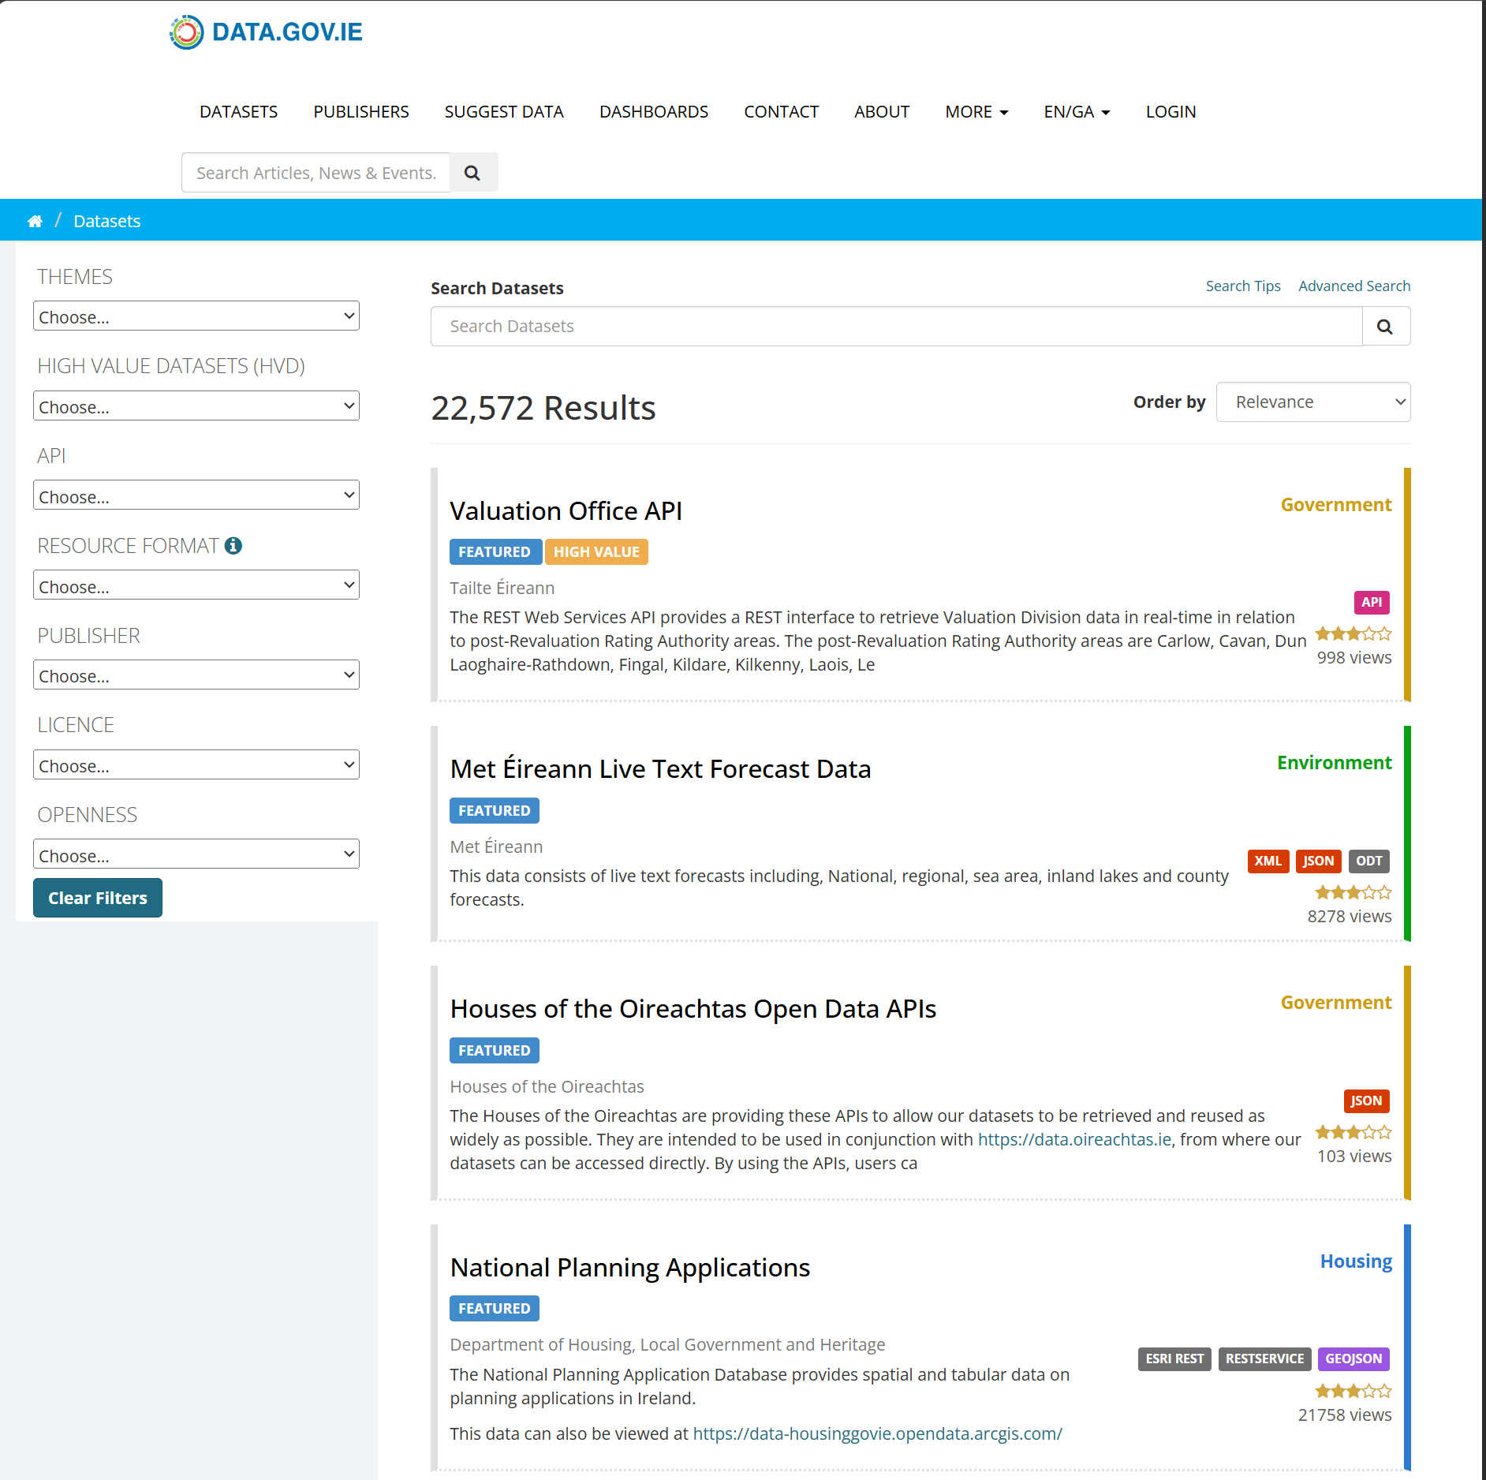
Figure 3: Data government portal
- CSO datasets (CSO, 2026)
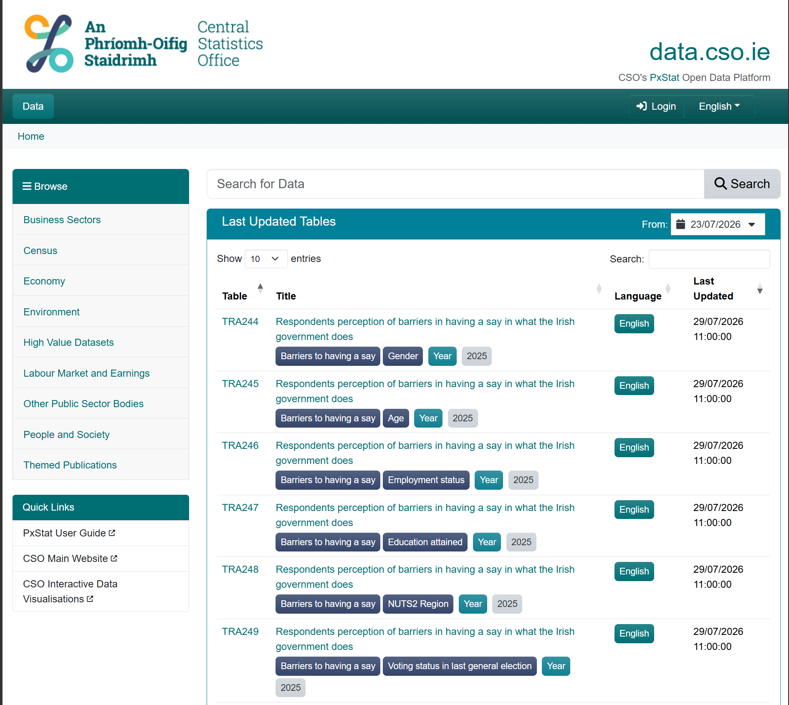
Figure 4: CSO datasets

- Kaggle datasets (Lia, 2025)
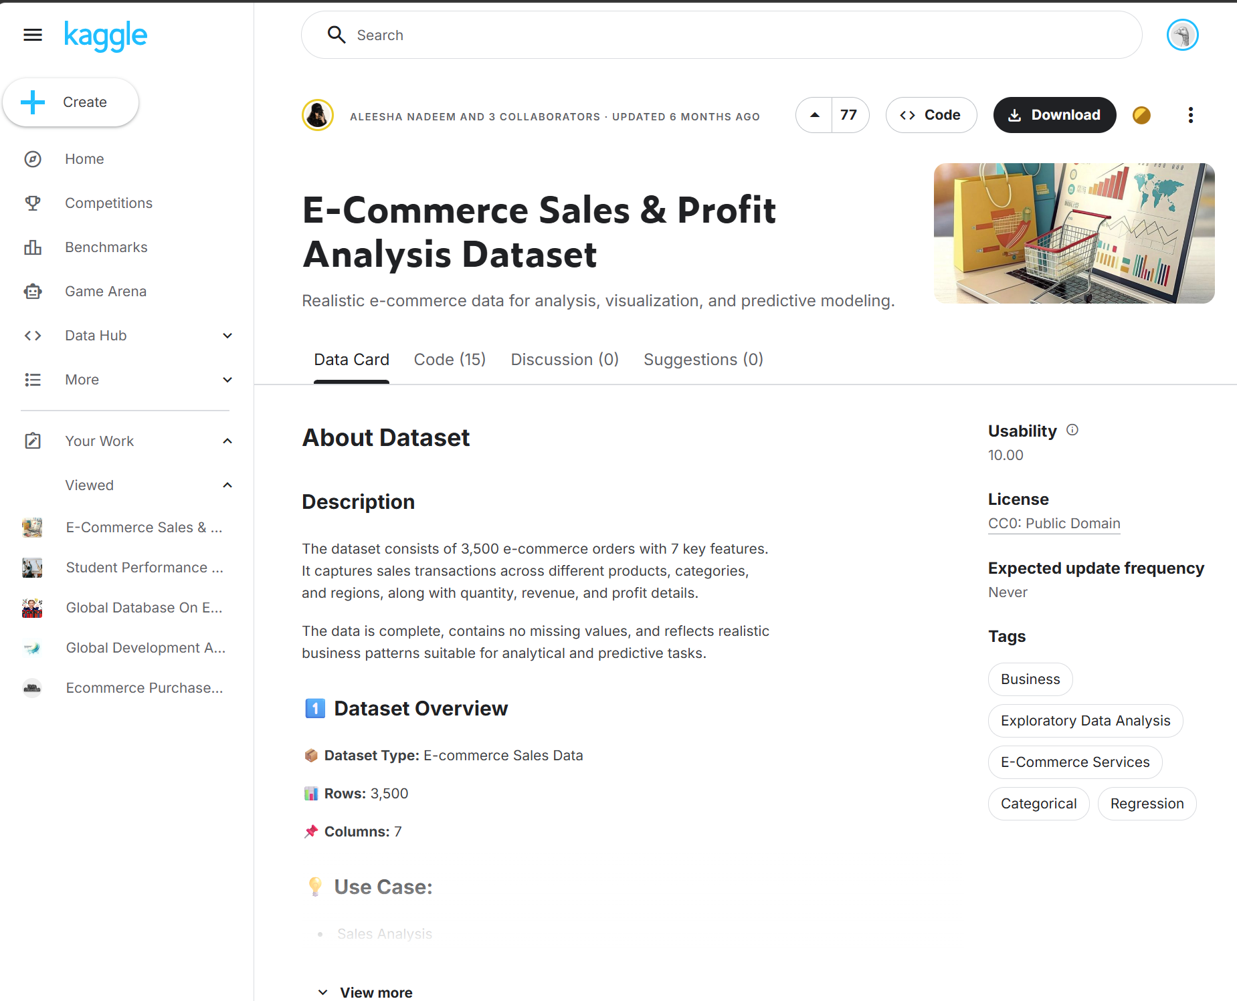
Figure 5: Kaggle Dataset
- SME operational data stored in SharePoint

3.2 Data Ingestion Layer
Components:
- File Loader (local Excel)
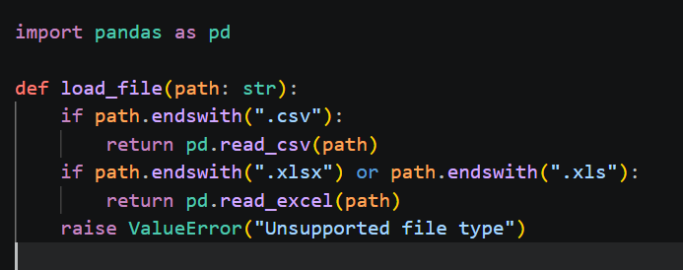
Figure 6: File Loader

- SharePoint Fetcher (Microsoft Graph API): Authentication using Azure AD App registration. It lists files in SME SharePoint folder.
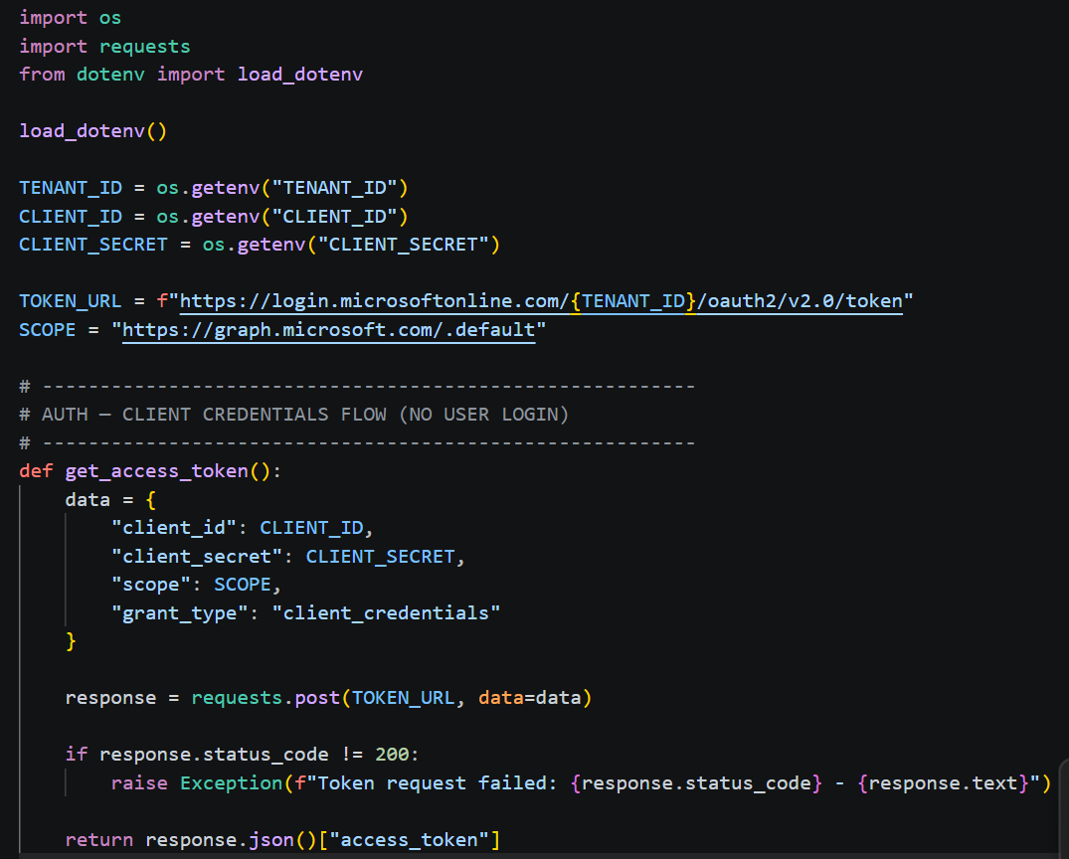
Figure 7: SharePoint fetcher
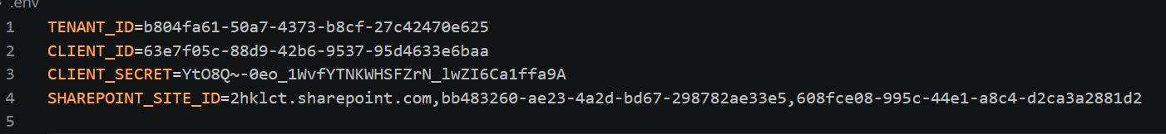
Figure 8: Azure AD App Details

3.3 Multi Agent Pipeline
A python based multi-agent system:
- Schema Agent – validates column structure and data types
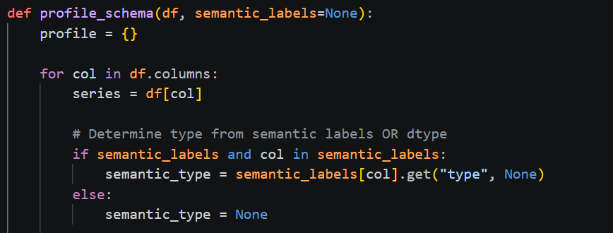
Figure 9: Schema Agent
- Anomaly Agent – detects outliers, suspicious zeros, numeric anomalies
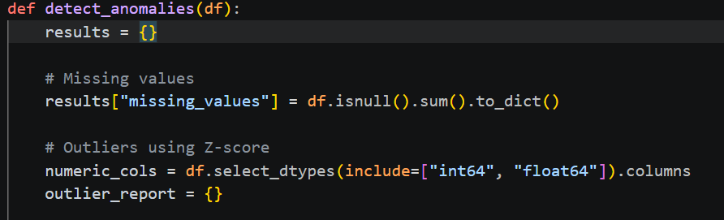
Figure 10: Anomaly Agent
- Schema Validator – performs structural checks
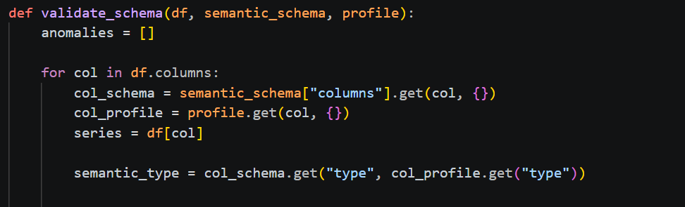
Figure 11: Schema Validator
- Row level Analyser – evaluates logical rules and row level contradictions
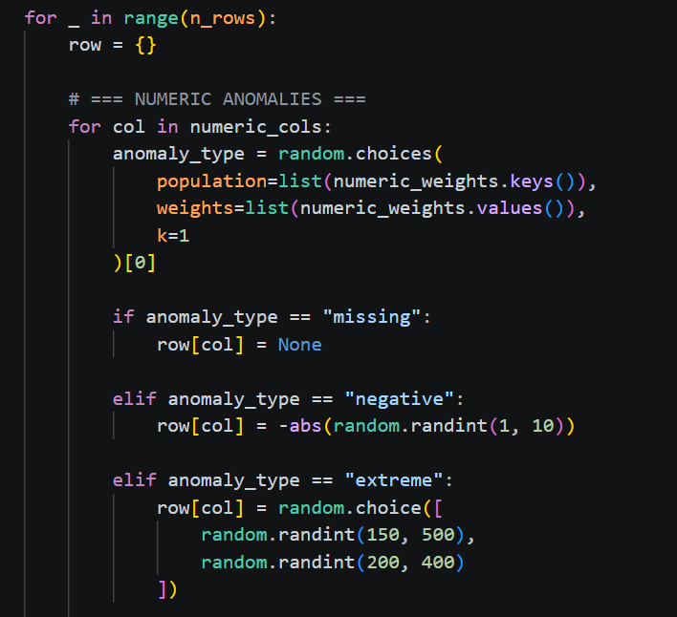
Figure 12: Row Level Analyzer

3.4 Evaluation & Fusion Layer
The multi-agent checks for duplication, severity scoring, consolidation of anomalies and row level anomaly fusion.
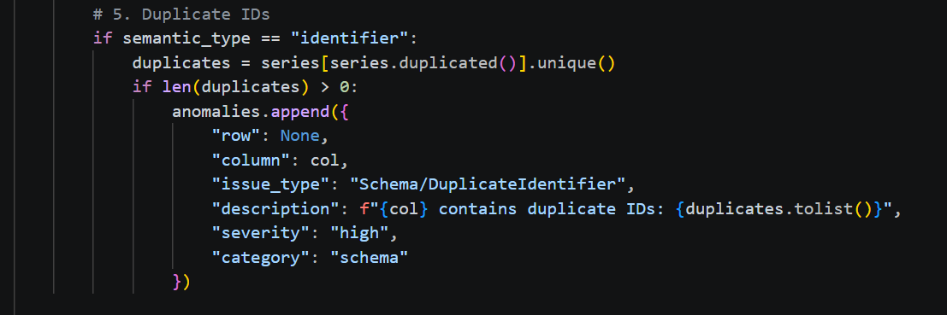
Figure 13:Duplication

3.5 Reporting Layer
An Excel anomaly and schema report is generated and highlighted for ease of identification. A machine-readable anomaly summary.
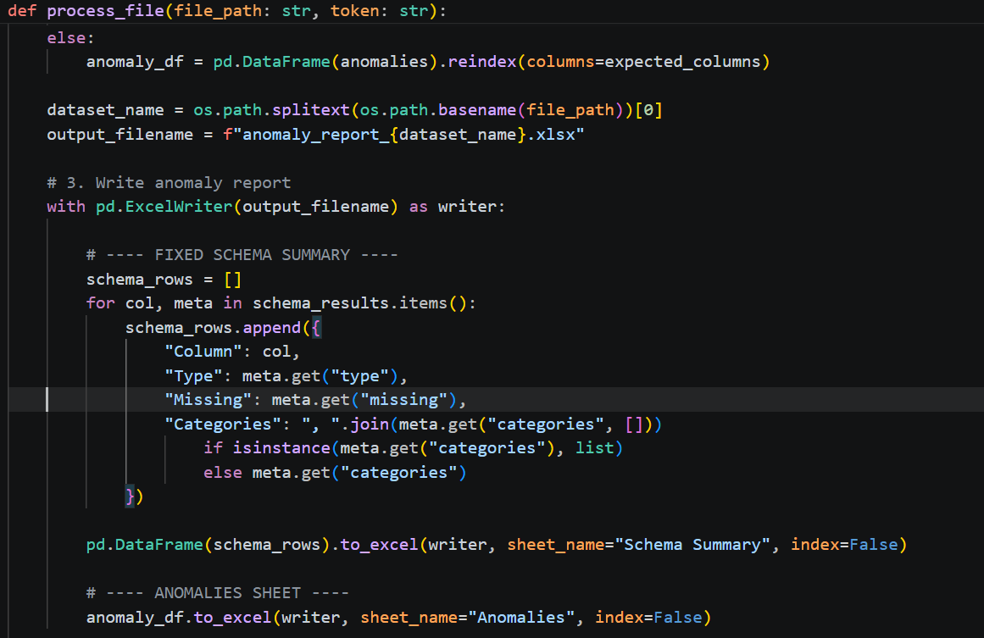
Figure 14: Reporting Layer

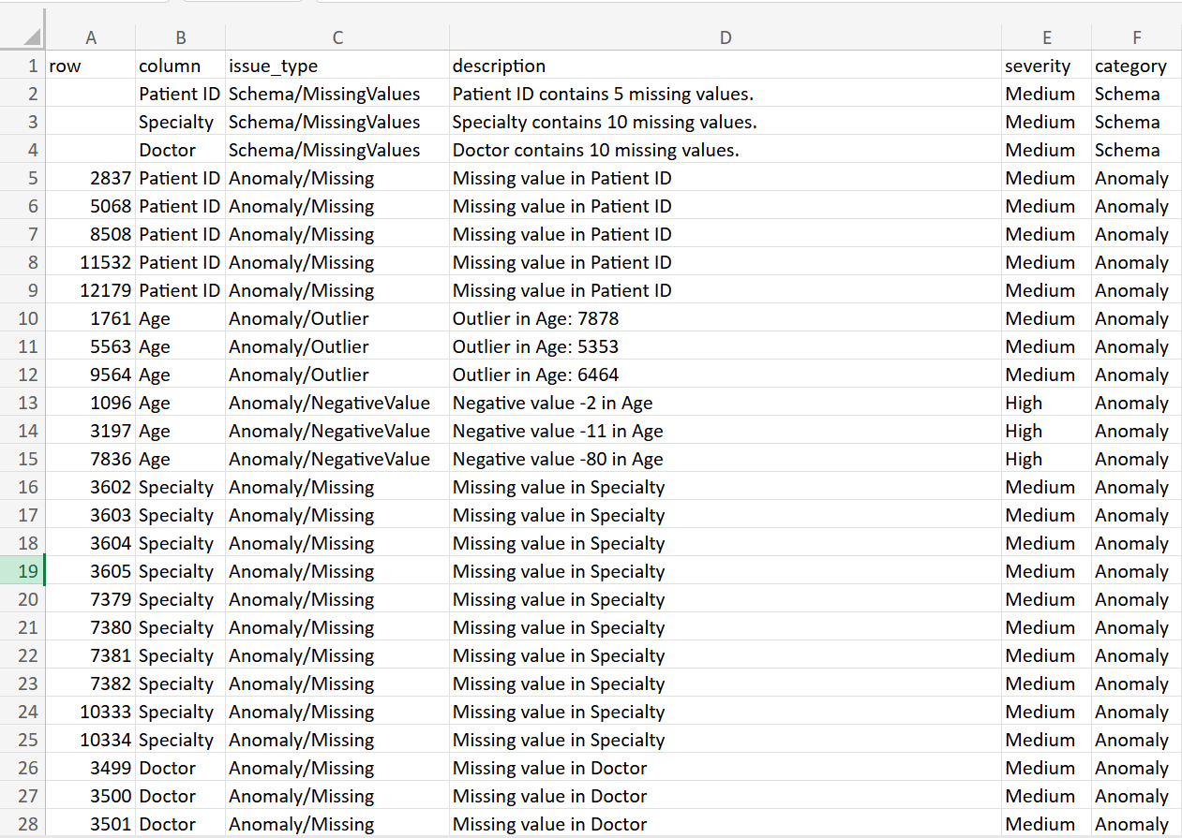
Figure 15: Excel Report Sheet (Anomaly/Schema)

3.6 SharePoint Output Layer
The processed report is uploaded in a Detected Error folder, original datasets is archived and maintains audit trial.
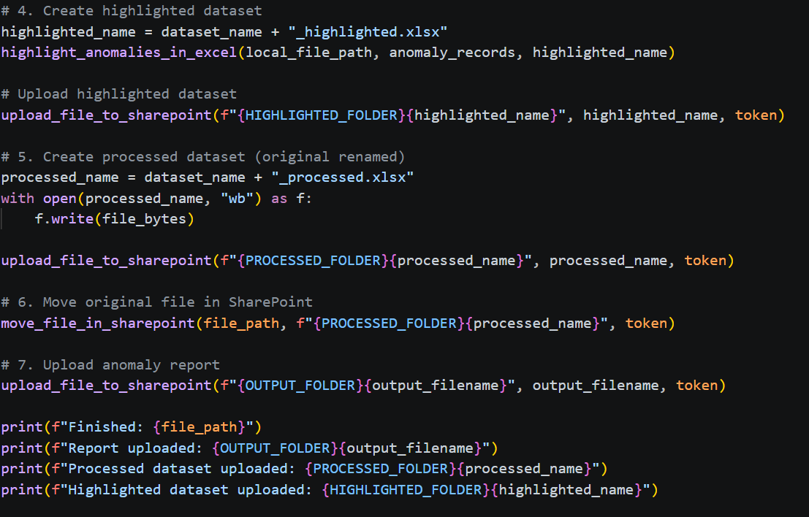
Figure 16: SharePoint Output Layer

3.7 Power Automate Notification Layer
It triggers once a new anomaly report, and schema report is generated and a Teams message is sent to SME staff.
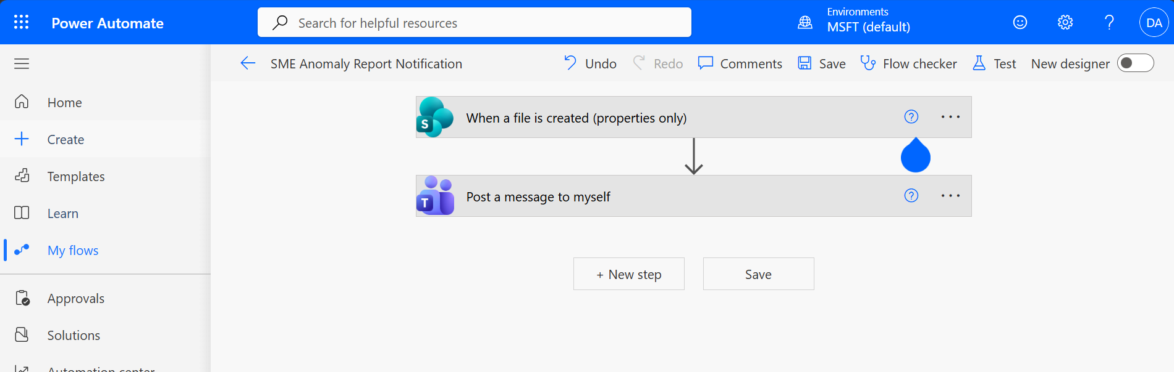
Figure 17: Notification Layer

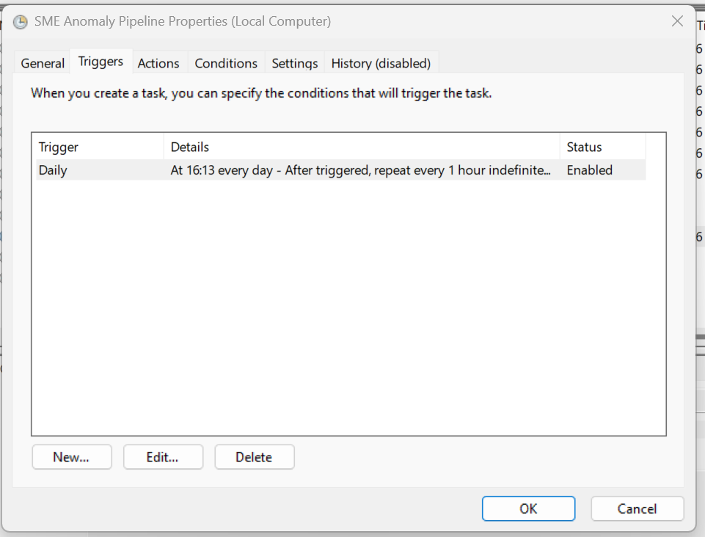
Figure 18:Task Scheduler
A Microsoft Team message is sent to the user when a new report is generated

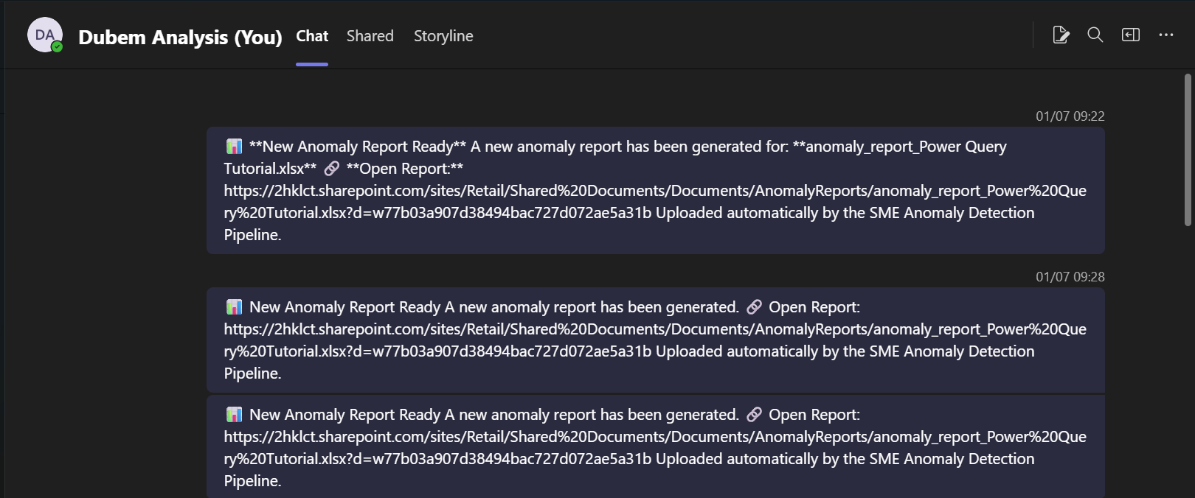
Figure 19: Microsoft Teams Notification

3.8 Pipeline Orchestration
The below code snippet shows the main pipeline that houses all agents and automation. It calls up the entire system.

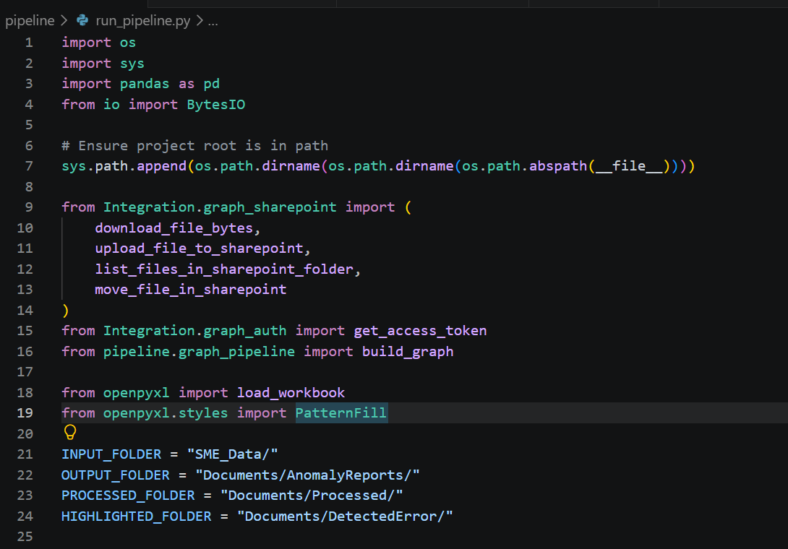
Figure 20: Orchestration

References
CSO. (2026) Home - CSO - Central Statistics Office. Central Statistics Office. Available at: https://www.cso.ie/en/index.html (Accessed: 7 July 2026).
Lia, N. (2025) Student Performance Factors. Kaggle. Available at: https://www.kaggle.com/datasets/lainguyn123/student-performance-factors?resource=download (Accessed: 21 June 2026).
Open Data Team. (2026) Datasets - Data.Gov.ie. Open Data Team Department of Public Expenditure Infrastructure Public Service Reform and Digitalization, Available at: https://data.gov.ie/dataset (Accessed: 7 July 2026).

